Q7. (a)

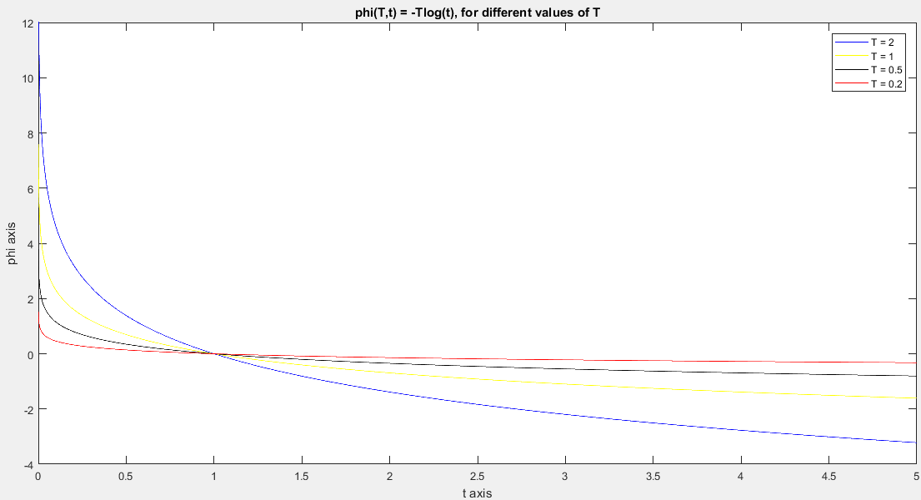

**Code:**

t=linspace(0,5,10000);

phi = log(t);

phi1 = (-2)*phi;

phi2 = -phi;

phi3 = -(0.5)*phi;

phi4 = -(0.2)*phi;

figure;

plot (t,phi1,'b');

hold on;

plot (t,phi2,'y');

hold on;

plot (t,phi3,'k');

hold on;

plot (t,phi4,'r');

hold on;

xlabel ('t axis');

ylabel ('phi axis');

title ('phi(T,t) = -Tlog(t), for different values of T');

xlim([0 5])

ylim([-4 12])

hold off;

legend('T = 2','T = 1','T = 0.5','T = 0.2');

Q7. (e)

>> taumain  
  
(The iterative values of xhat has been shown for each value of tau. The final values are shown in bold.)

Iteration number: 1  
Value of tau: 1  
The number of iterations: 151

xhat =

**0.1890**

**0.1382**

**0.0739**

**0.8807**

Iteration number: 2  
Value of tau: 5.000000e-01  
The number of iterations: 158

xhat =

0.1890 **0.1320**

0.1382 **0.1055**

0.0739 **0.0413**

0.8807 **0.8665**

Iteration number: 3  
Value of tau: 2.500000e-01  
The number of iterations: 138

xhat =

0.1890 0.1320 **0.0925**

0.1382 0.1055 **0.0793**

0.0739 0.0413 **0.0222**

0.8807 0.8665  **0.8784**

Iteration number: 4  
Value of tau: 1.250000e-01  
The number of iterations: 835

xhat =

0.1890 0.1320 0.0925 **0.0651**

0.1382 0.1055 0.0793 **0.0586**

0.0739 0.0413 0.0222 **0.0116**

0.8807 0.8665 0.8784 **0.9004**

Iteration number: 5  
Value of tau: 6.250000e-02  
The number of iterations: 1564

xhat =

0.1890 0.1320 0.0925 0.0651 **0.0459**

0.1382 0.1055 0.0793 0.0586 **0.0427**

0.0739 0.0413 0.0222 0.0116 **0.0060**

0.8807 0.8665 0.8784 0.9004 **0.9230**

Iteration number: 6  
Value of tau: 3.125000e-02  
The number of iterations: 2953

xhat =

0.1890 0.1320 0.0925 0.0651 0.0459 **0.0324**

0.1382 0.1055 0.0793 0.0586 0.0427 **0.0308**

0.0739 0.0413 0.0222 0.0116 0.0060 **0.0030**

0.8807 0.8665 0.8784 0.9004 0.9230 **0.9424**

Iteration number: 7  
Value of tau: 1.562500e-02  
The number of iterations: 5596

xhat =

0.1890 0.1320 0.0925 0.0651 0.0459 0.0324 **0.0229**

0.1382 0.1055 0.0793 0.0586 0.0427 0.0308 **0.0221**

0.0739 0.0413 0.0222 0.0116 0.0060 0.0030 **0.0015**

0.8807 0.8665 0.8784 0.9004 0.9230 0.9424 **0.9577**

Iteration number: 8  
Value of tau: 7.812500e-03  
The number of iterations: 10583

xhat =

0.1890 0.1320 0.0925 0.0651 0.0459 0.0324 0.0229 **0.0162**

0.1382 0.1055 0.0793 0.0586 0.0427 0.0308 0.0221 **0.0158**

0.0739 0.0413 0.0222 0.0116 0.0060 0.0030 0.0015 **0.0008**

0.8807 0.8665 0.8784 0.9004 0.9230 0.9424 0.9577 **0.9694**

Iteration number: 9  
Value of tau: 3.906250e-03  
The number of iterations: 19986

xhat =

0.1890 0.1320 0.0925 0.0651 0.0459 0.0324 0.0229 0.0162 **0.0114**

0.1382 0.1055 0.0793 0.0586 0.0427 0.0308 0.0221 0.0158 **0.0112**

0.0739 0.0413 0.0222 0.0116 0.0060 0.0030 0.0015 0.0008 **0.0004**

0.8807 0.8665 0.8784 0.9004 0.9230 0.9424 0.9577 0.9694 **0.9780**

Iteration number: 10  
Value of tau: 1.953125e-03  
The number of iterations: 19999

xhat =

0.1890 0.1320 0.0925 0.0651 0.0459 0.0324 0.0229 0.0162 0.0114 **0.0080**

0.1382 0.1055 0.0793 0.0586 0.0427 0.0308 0.0221 0.0158 0.0112 **0.0080**

0.0739 0.0413 0.0222 0.0116 0.0060 0.0030 0.0015 0.0008 0.0004 **0.0002**

0.8807 0.8665 0.8784 0.9004 0.9230 0.9424 0.9577 0.9694 0.9780 **0.9839**

>>

**Codes:**

***taumain.m***

for i = 1:10

tau = 2^(1-i);

fprintf('Iteration number: %i\n', i);

fprintf('Value of tau: %d\n', tau);

if tau==1

xxx = [1; 2; 3; 4];

xhat(:,i) = tauf(tau,xxx)

else

xhat(:,i) = tauf(tau,xhat(:,i-1))

end

end

***tauf.m***

function ret = tauf(taunum,xvect)

A = [1 -1 -1 0;2 0 3 0;-2 0 1 1;1 4 0 1;0 3 1 1];

y = [1;-1;1;2;0];

k = 1;

x(:,k) = xvect;

while (k < 20000)

d = 2*y'*A - 2*x(:,k)'*(A'*A) + taunum*[1/x(1,k) 1/x(2,k) 1/x(3,k) 1/x(4,k)];

d = d';

if (max(abs(d)) < (10^-4))

break

end

a = 1;

for i = 1:4

x(i,k+1) = x(i,k) + a*d(i);

end

while ((x(1,k+1) < 0)||(x(2,k+1) < 0)||(x(3,k+1) < 0)||(x(4,k+1) < 0))

a = a/2;

for i = 1:4

x(i,k+1) = x(i,k) + a*d(i);

end

end

pro(k) = x(1,k)*x(2,k)*x(3,k)*x(4,k);

pro(k+1) = x(1,k+1)*x(2,k+1)*x(3,k+1)*x(4,k+1);

fx(k+1) = -taunum*log(pro(k+1)) + (norm(y - A*x(:,k+1)))^2;

fx(k) = -taunum*log(pro(k)) + (norm(y - A*x(:,k)))^2;

while (fx(k+1) >= fx(k))

a = a/2;

for i = 1:4

x(i,k+1) = x(i,k) + a*d(i);

end

pro(k+1) = x(1,k+1)*x(2,k+1)*x(3,k+1)*x(4,k+1);

fx(k+1) = -taunum*log(pro(k+1)) + (norm(y - A*x(:,k+1)))^2;

end

k = k+1;

end

ret = x(:,k-1);

fprintf('The number of iterations: %i\n\n', k-1)

end